Bisection Method

#include<iostream.h>

#include<conio.h>

#include<math.h>

#define EPS 0.000001

#define F(x) log(x)-cos(x)

void bim(float*a, float*b, float*root, float*s, int*count); void main()

{ int count;

float a, b, root, s;

cout<<"SOLUTION BY BISECTION METHOD:"<<endl; cout<<"input starting values:"<<endl;
cin>>a>>b;

bim(&a, &b, &root, &s, &count); if (s==0)
{ cout<<"starting points donot bracket any root"<<endl;

cout<<"check whether they bracket EVEN roots."<<endl;

}

else

{ cout<<"root="<<root<<endl; float fun = F(root); cout<<"f(root)="<<fun<<endl;

Page 1
cout<<"Iterations="<<count<<endl;

}

getch();

clrscr();

}

void bim(float*a, float*b, float*root, float*s, int*count)

{ float x1, x2, x0, f0, f1, f2; x1=*a;
x2=*b;

f1=F(x1);

f2=F(x2); if(f1*f2> 0) { *s=0;

return;

}

else

{ *count=0; begin: x0=(x1+x2)/2.0; f0=F(x0); if(f0==0)
{ *s=1; *root=x0; return;

Page 2
}

if(f1*f0<0)

{ x2=x0;

}

else

{ x1=x0; f1=f0;

}

if(fabs((x2-x1)/x2) < EPS)

{ *s=1; *root=(x1+x2)/2.0;
return;

}

else

{ *count=*count+1; goto begin;

}

}

}

Page 3
Output of Bisection Method
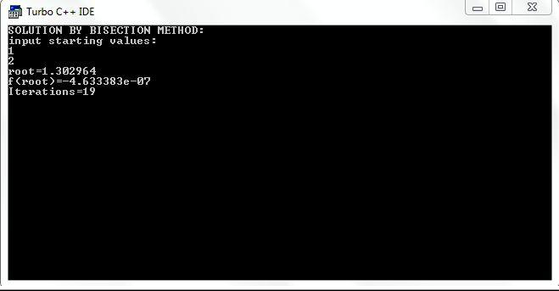

Page 4
Secant Method

#include<iostream.h>

#include<conio.h>

#include<math.h>

#define EPS 0.000001

#define MAXIT 50

#define F(x) exp(x)-x-2

int sec(float*a, float*b, float*x1, float*x2, float*root, int*count, int*status); void main()
{ float a, b, root, x1, x2, fr; int count, status; clrscr();

cout<<"SOLUTION BY SECANT METHOD"<<endl; cout<<"Input two starting points:"<<endl; cin>>a>>b;

sec(&a, &b, &x1, &x2, &root, &count, &status); if(status==1)

{ cout<<"DIVISION BY ZERO"<<endl; cout<<"last x1="<<x1<<endl<<"last x2="<<x2<<endl;
cout<<"number of iterations="<<count<<endl;

}

if(status==2)

Page 5
{ cout<<"NO CONVERGENCE IN"<<MAXIT<<" ITERATIONS."<<endl;

}

else

{ cout<<"root="<<root<<endl; fr=F(root);
cout<<"function Value at root="<<fr<<endl; cout<<"no. of iterations="<<count<<endl;

}

getch();

}

int sec(float*a, float*b, float*x1, float*x2, float*root, int*count, int*status)

{ float x3, f1, f2, error; *x1=*a;

*x2=*b;

f1=F(*a);

f2=F(*b);

*count=1;

begin:

if (fabs(f1-f2)<=1.E-10) { *status=1;

return 0;

}

x3=*x2-f2*(*x2-*x1)/(f2-f1);

error=fabs((x3-*x2)/x3);

Page 6
if (error>EPS)

{ if (*count==MAXIT) { *status=2;

return 0;

}

else

{ *x1=*x2;

}

*x2=x3;

f1=f2;

f2=F(x3);

*count=*count+1; goto begin;

}

else

{ *root=x3; *status=3;

return 0;

}

}

Page 7
Output of Secant Method
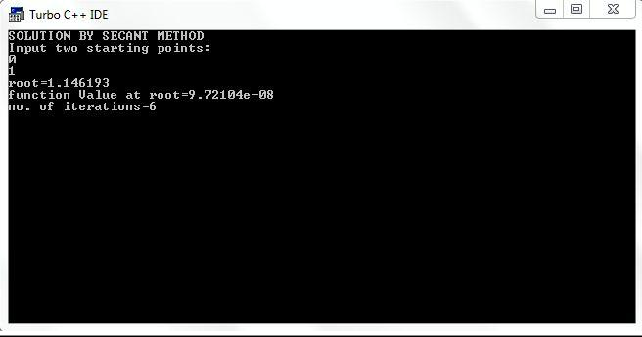

Page 8
Newton-Raphson Method

#include<iostream.h>

#include<conio.h>

#include<math.h>

#define EPS 0.000001

#define MAXIT 20

#define F(x) (x)*(x)*(x)+(x)*(x)-3*(x)-3

#define FD(x) 3*(x)*(x)+2*(x)-3

void main()

{ clrscr(); int count;

float x0, xn, fx, fdx, fxn;

cout<<"SOLUTION BY NEWTON RAPHSON'S METHOD"<<endl; cout<<"input initial value of x:"<<endl;

cin>>x0;

count=1;

begin:

fx=F(x0);

fdx=FD(x0); xn=x0-fx/fdx;

if (fabs((xn-x0)/xn) < EPS) { cout<<"root="<<xn<<endl;

Page 9
fxn =F(xn);

cout<<"function value="<<fxn<<endl;

cout<<"no. of iterations="<<count<<endl;

}

else

{ x0=xn; count=count+1; if(count<MAXIT)

{ goto begin;

}

else

{ cout<<"SOLUTION DOESNOT CONVERGE."<<endl; cout<<"iterations="<<MAXIT<<endl;

}

}

getch();

}

Page 10
Output of Newton-Raphson Method
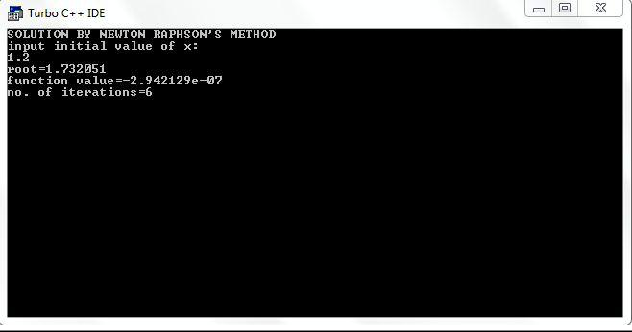

Page 11
Fixed-point Iteration Method

#include<iostream.h>

#include<conio.h>

#include<iomanip.h>

#include<math.h>

#define EPS 0.000001

#define G(x) 2.0-(x)*(x)

void main()

{ clrscr();

int MAXIT, i; float x0, x, error;

cout<<"SOLUTON BY FIXED POINT METHOD"<<endl; cout<<"input initial estimate of a root:"<<endl; cin>>x0;

cout<<"Maximum iterations allowed:"<<endl; cin>>MAXIT;
cout<<"iteration value of X error:"<<endl; for(i=1; i<=MAXIT; i++)

{ x = G(x0); error=fabs((x-x0)/x); cout<<setw(10)<<i<<setw(10)<<x<<setw(10.8)<<error<<endl; if(error < EPS)
Page 12
goto end;

else

x0=x;

}

cout<<"process doesnot converge to a root"<<endl;

cout<<"exit from the iteratoion loop"<<endl;

end:

;

getch();

}

Page 13
Output of Fixed-point Iteration Method
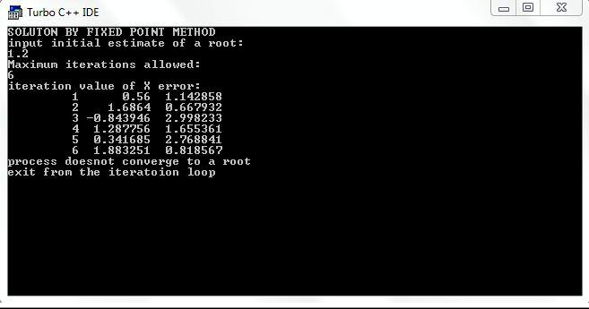

Page 14
Lagrange’s Interpolation

#include<iostream.h>

#include<math.h>

#include<conio.h>

#define MAX 10

void main()

{ clrscr(); int n, i, j;

float x[MAX], f[MAX], fp, lf, sum, xp; cout<<"input no. of data points:"<<endl; cin>>n;

cout<<"input values of x and fx"<<endl; cout<<"one set on each line"<<endl; for(i=1; i<=n; i++)

cin>>x[i]>>f[i];

cout<<"input x where the interpolation is required:"<<endl; cin>>xp;

sum=0.0; for(i=1; i<=n; i++) { lf=1.0;

for(j=1; j<=n; j++) { if(i!=j)

Page 15
lf=lf*(xp-x[j])/(x[i]-x[j]);

}

sum= sum+lf*f[i];

}

fp= sum;

cout<<" LAGRANGIAN INTERPOLATION "<<endl; cout<<"interpolated function value:"<<endl; cout<<"at x= "<<xp<<" it is "<<fp<<endl; getch();

}

Page 16
Output of Lagrange’s Interpolation
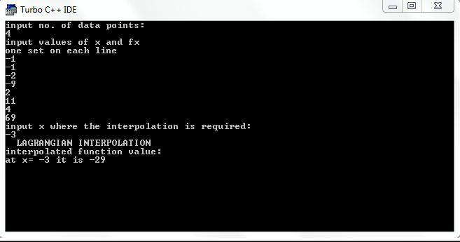

Page 17
Newton’s Interpolation

#include<iostream.h>

#include<conio.h>

void main()

{ clrscr(); int i, j, n;
float xp, fp, sum, pi, x[10], f[10], a[10], d[10][10]; cout<<"input numbers of data points:"<<endl; cin>>n;

cout<<"Input values of x and fx"<<endl; cout<<"one set on each line"<<endl; for(i=1; i<=n; i++)

cin>>x[i]>>f[i]; for(i=1; i<=n; i++) d[i][1]=f[i]; for(j=2; j<=n; j++) for(i=1; i<=n-j+1; i++)

d[i][j]=(d[i+1][j-1]-d[i][j-1])/(x[i+j-1]-x[i]); for(j=1; j<=n; j++)
a[j]=d[1][j];

cout<<"enter xp where interpolation is required:"<<endl; cin>>xp;

Page 18
sum=a[1];

for(i=2; i<=n; i++)

{ pi =1.0;

for(j=1; j<=i-1; j++)

pi=pi*(xp-x[j]);

sum=sum+a[i]*pi;

}

fp=sum;

cout<<"NEWTON's INTERPOLATION"<<endl; cout<<"***********************"<<endl; cout<<endl;

cout<<"interpolation values"<<endl;

cout<<"at x="<<xp<<" it is"<<fp<<endl;

getch();

}

Page 19
Output of Newton’s Interpolation
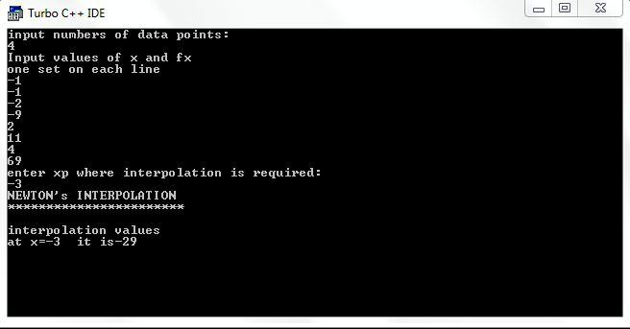

Page 20
Fitting a straight line

#include<iostream.h>

#include<conio.h>

#include<math.h>

#define MAX 10

#define EPS 0.000001

void main()

{ clrscr(); int i, n;
float x[10], y[10];

float sumx, sumy, sumxx, sumxy, xmean, ymean; float denom;
float a,b;

cout<<"LINEAR REGRESSION METHOD"<<endl; cout<<endl;
cout<<"input the no. of data points:"<<endl; cin>>n;

cout<<"input x and y values"<<endl; cout<<"one set on each line:"<<endl; for(i=1; i<=n; i++) cin>>x[i]>>y[i];

sumx=0.0;

Page 21
sumy=0.0;

sumxx=0.0;

sumxy=0.0;

for(i=1; i<=n; i++)

{ sumx=sumx+ x[i]; sumy=sumy+ y[i]; sumxx=sumxx+ x[i]*x[i];

sumxy= sumxy+ x[i]*y[i];

}

xmean=sumx/n;

ymean=sumy/n;

denom=n*sumxx-sumx*sumx;

if(fabs(denom)>EPS)

{ b=(n*sumxy-sumx*sumy)/denom; a=ymean-b*xmean;
cout<<"linear regression line y=a+bx"<<endl; cout<<"the coefficients are:"<<endl; cout<<"a= "<<a<<endl;

cout<<"b= "<<b<<endl;

}

else

cout<<"NO SOLUTION"<<endl;

getch();

}

Page 22
Output of fitting a straight line
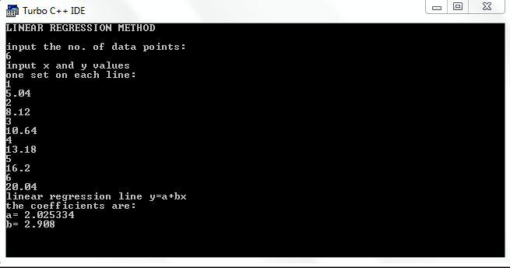

Page 23
Differentiation using newton's interpolating polynomial

#include<iostream.h>

#include<conio.h>

#include<math.h>

void main()

{ int i, j, k, n;

float x[10], f[10], a[10], d[10][10], xp, dif, sum, p; clrscr();

cout<<"NUMERICAL DIFFERENTIATION USING NEWTON's POLYNOMIAL"<<endl;

cout<<"input no. of data points:"<<endl;

cin>>n;

cout<<"input values of x and f(x)"<<endl;

cout<<"one set on each line"<<endl;

for(i=1; i<=n; i++)

cin>>x[i]>>f[i];

for(i=1; i<=n; i++)

d[i][1] = f[i];

for(j=2; j<=n; j++)

for(i=1; i<=n-j+1; i++)

d[i][j]=(d[i+1][j-1]-d[i][j-1])/(x[i+j-1]-x[i]);

for(j=1; j<=n; j++)

Page 24
a[j]=d[1][j];

cout<<"input xp where derivative is required:"<<endl;

cin>>xp;

dif =a[2];

for(k=3; k<=n; k++)

{ sum= 0.0; for(i=1; i<=k-1; i++) { p= 1.0;
for(j=1; j<=k-1; j++) { if (i==j)

continue;

p= p*(xp-x[j]);

}

sum= sum+p;

}

dif=dif+a[k]*sum;

}

cout<<"derivative at x= "<<xp<<" is "<<dif<<endl; getch();

}

Page 25
Output of differentiation using newton's interpolating polynomial
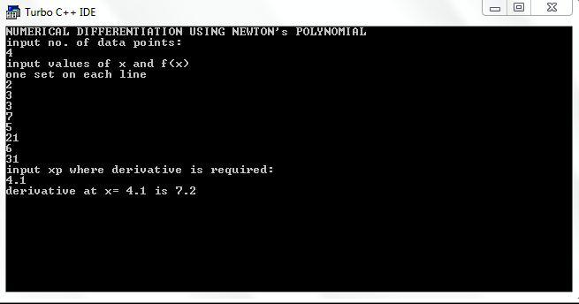

Page 26
Trapezoidal rule for given function

#include<iostream.h>

#include<conio.h>

#include<math.h>

float F(float x);

void main()

{ int n, i;

float a, b, h, sum, ict; float F(float x); cout<<endl<<"TRAPEZOIDAL RULE:"<<endl; cout<<"input initial value of x"<<endl; cin>>a;

cout<<"input final value of x:"<<endl; cin>>b;

cout<<"input the segment width:"<<endl; cin>>h;
if(a!=b)

{ n= (b-a)/h;

sum = (F(a) + F(b))/2.0;

for(i=1; i<=n-1; i++)

{ sum = sum + F(a+i*h);

}

Page 27
ict = sum * h;

cout<<endl;

cout<<"Integration between "<<a<<" and "<<b<<" when h= "<<h<<" is "<<ict<<endl;

cout<<endl;

}

else

{ cout<<"exiting"<<endl;

}

getch();

clrscr();

}

float F(float x)

{ float f;

f = 1.0-exp(-x/2.0);

return (f);

}

Page 28
Output of trapezoidal rule for given function
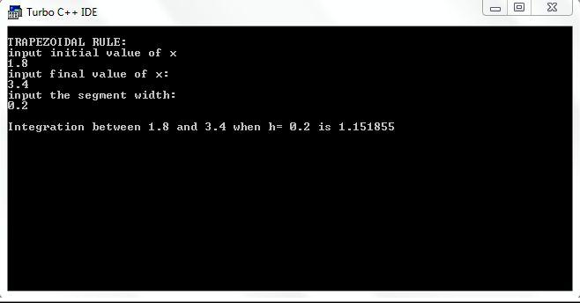

Page 29
Trapezoidal rule for tabulated function

#include<iostream.h>

#include<conio.h>

#include<math.h>

#define MAX 15

void main()

{ int n, n1, n2, i;

float a, b, h, sum, ict, x[MAX], y[MAX]; clrscr();
cout<<endl;

cout<<"input the no. of data points:"<<endl; cin>>n;
cout<<"input the tablated values"<<endl; cout<<"one set at each line:"<<endl; for(i=1; i<=n; i++)

cin>>x[i]>>y[i];

cout<<"input initial value of x:"<<endl; cin>>a;

cout<<"input final value of x:"<<endl; cin>>b;
cout<<"input width of segments:"<<endl; cin>>h;

Page 30
n1=(int)(fabs(a-x[1])/h+1.5);

n2=(int)(fabs(b-x[1])/h+1.5);

sum=0.0;

for(i=n1; i<=n2-1; i++)

sum=sum+y[i]+y[i+1];

ict=sum*h/2.0;

cout<<"integral from "<<a<<" to "<<b<<" is "<<ict<<endl;

getch();

}

Page 31
Output of trapezoidal rule for tabulated function
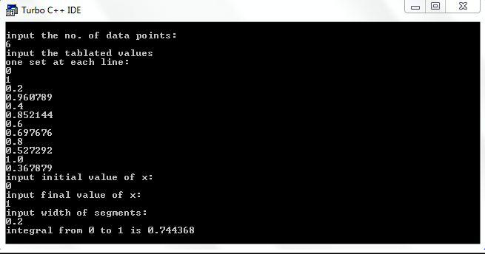

Page 32
Simpson’s 1 by 3 using tabulated value

#include<iostream.h>

#include<conio.h>

#include<math.h>

#include<iomanip.h>

void main()

{ clrscr();

int i, n, n1, n2, m, l;

float x[15], y[15], a, b, h, sum, ics, i1, i2; cout<<endl;
cout<<"input no. of data points:"<<endl; cin>>n;
cout<<"input table values set by set"<<endl; cout<<"one set on each line"<<endl; for(i=1; i<=n; i++)

cin>>x[i]>>y[i];

cout<<"input initial value of x:"<<endl; cin>>a;

cout<<"input final value of x:"<<endl; cin>>b;
cout<<"input the segment width:"<<endl; cin>>h;

Page 33
n1 = (int)(fabs(a-x[1])/h+1.5);

n2 = (int)(fabs(b-x[1])/h+1.5);

m=n2-n1;

if(m%2==0)

{ i2=0.0; l=n2-2;

}

else

{ i2=(y[n2-1]+y[n2])*h/2.0; l=n2-3;

}

sum=0.0;

for(i=n1; i<=l; i=i+2)

sum=sum+y[i]+4*y[i+1]+y[i+2];

i1=sum*h/3.0;

ics=i1+i2;

cout<<"integral from "<<a<<" to "<<b<<" is "<<ics;

getch();

clrscr();

}

Page 34
Output of Simpson’s 1 by 3 using tabulated value
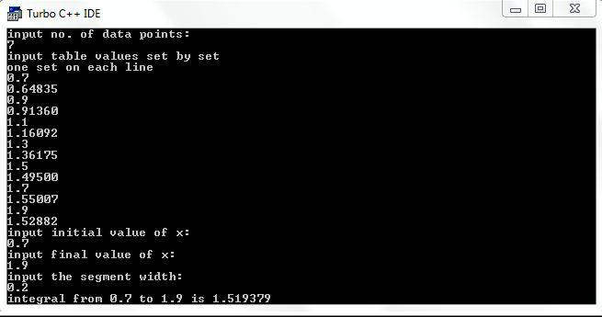

Page 35
Simpson's 3 by 8 rule integrating a function

#include<iostream.h>

#include<conio.h>

#include<math.h>

#define F(x) 1-exp(-(x)/2.0)

void main()

{ clrscr(); int n, m, i;

float a, b, h, sum, ics, x, f1, f2, f3, f4; cout<<"Initial value of x"<<endl; cin>>a;

cout<<"Final value of x"<<endl; cin>>b;
cout<<"Number of segments n (divisible by 3)"<<endl; cin>>n;
h=(b-a)/n; m=n/3; sum=0.0; x=a; f1=F(x); for(i=0;i<=m-1;i++) { f2=F((x+h));

Page 36
f3=F((x+2*h));

f4=F((x+3*h));

sum=sum+f1+3*f2+3*f3+f4;

f1=f4;

x=x+3*h;

}

ics=sum*3*h/8.0;

cout<<"Integral from "<<a<<" to "<<b<<endl;

cout<<"when h= "<<h<<" is "<<ics<<endl;

getch();

}

Page 37
Output of Simpson's 3 by 8 rule integrating a function
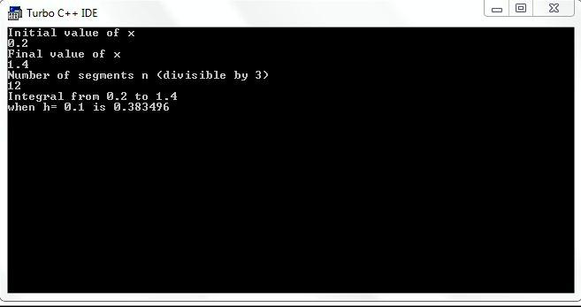

Page 38
Gauss siedel iteration method

#include<iostream.h>

#include<conio.h>

#include<iomanip.h>

#include<math.h>

#define MAXIT 50

#define EPS 0.000001

void gaseid(int n, float a[10][10], float b[10], float x[10], int *count, int *status); void main()
{ float a[10][10], b[10], x[10]; int i, j, n, count, status;

cout<<"** SOLUTION BY GUASS SEIDEL ITERATION METHOD **"<<endl; cout<<"input the size of the system:"<<endl;
cin>>n;

cout<<"input coefficients, a(i.j)"<<endl; cout<<"one row on each line"<<endl; for(i=1; i<=n; i++)

for(j=1; j<=n; j++) cin>>a[i][j];
cout<<"input vector b:"<<endl; for(i=1; i<=n; i++)

cin>>b[i];

Page 39
gaseid(n, a, b, x, &count, &status);

if(status==2)

{ cout<<"no CONVERGENCE in "<<MAXIT<<" iterations."<<endl<<endl<<endl;

}

else

{ cout<<"SOLUTION VECTOR X"<<endl; for(i=1; i<=n; i++) cout<<setw(15.6)<<x[i]<<endl;

cout<<"iterations= "<<count;

}

getch();

}

void gaseid(int n, float a[10][10], float b[10], float x[10], int *count, int *status)

{ int i, j, key; float sum, x0[10]; for(i=1; i<=n; i++) x0[i]=b[i]/a[i][i]; *count=1; begin:

key=0;

for(i=1; i<=n; i++) { sum=b[i];

for(j=1; j<=n; j++) { if(i==j)

Page 40
continue;

sum=sum-a[i][j]*x0[j];

}

x[i]=sum/a[i][i];

if(key==0)

{ if(fabs((x[i]-x0[i])/x[i])>EPS) key=1;

}

}

if(key==1)

{ if(*count==MAXIT) { *status=2;
return;

}

else

{ *status=1; for(i=1; i<=n; i++)
x0[i]=x[i];

}

*count=*count+1;

goto begin;

}

return;

}

Page 41
Output of Gauss siedel iteration method
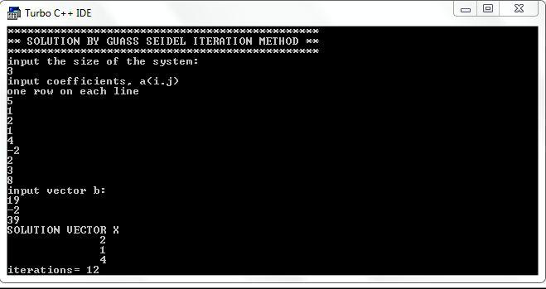

Page 42
Euler’s Method

#include<iostream.h>

#include<conio.h>

#include<math.h>

#include<iomanip.h>

float func(float x, float y);

void main()

{ clrscr(); int i, n;
float x, y, xp, h, dy; float func(float, float); cout<<endl;

cout<<"SOLUTION BY THE EULER's METHOD"<<endl; cout<<"input the initial values of x and y:"<<endl; cin>>x>>y;

cout<<"input the x at which y is required:"<<endl; cin>>xp;

cout<<"input the step size, h:"<<endl; cin>>h;
n = (int) ((xp-x)/h + 0.5); for(i=1; i<=n; i++)

{ dy = h * func(x, y);

Page 43
x = x + h;

y = y + dy;

cout<<setw(5)<<i<<setw(10.6)<<x<<setw(10.6)<<y<<endl;

}

cout<<"the value of y at x = "<<x<<" is "<<y<<endl;

getch();

clrscr();

}

float func(float x, float y)

{ float f;

f = x + y + x*y;

return (f);

}

Page 44
Output of Euler’s Method
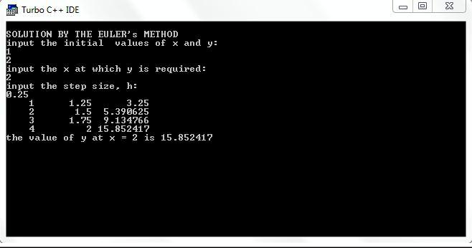

Page 45
Heun’s Method

#include<iostream.h>

#include<conio.h>

#include<math.h>

#include<iomanip.h>

float func(float x, float y);

void main()

{ clrscr(); int i, n;
float x, y, xp, h, m1, m2; float func(float, float); cout<<endl;

cout<<"SOLUTION BY THE HEUN's METHOD"<<endl; cout<<endl;

cout<<"input initial values of x and y:"<<endl; cin>>x>>y;
cout<<"input x at which y is required:"<<endl; cin>>xp;

cout<<"input the step size, h:"<<endl; cin>>h;
n = (int) ((xp - x)/h + 0.5); for(i=1; i<=n; i++)

Page 46
{ m1 = func(x, y);

m2 = func(x+h, y+m1*h);

  - = x + h;

  - = y + 0.5 * h * (m1 + m2);

cout<<setw(7)<<i<<setw(15.9)<<x<<setw(15.9)<<y<<endl;

}

cout<<"the value of y at x = "<<x<<" is "<<y;

getch();

clrscr();

}

float func(float x, float y)

{ float f;

f = -y/(2*y + 1);

return(f);

}

Page 47
Output of Heun’s Method
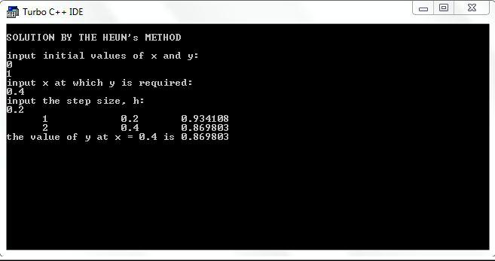

Page 48
Runge-Kutta Method

#include<iostream.h>

#include<conio.h>

#include<math.h>

#include<iomanip.h>

float func(float x, float y);

void main()

{ clrscr(); int i, n;
float x, y, xp, h, m1, m2, m3, m4; float func(float, float); cout<<endl; cout<<"******************************************"<<endl; cout<<"SOLUTION BY 4th ORDER RUNGE- KUTTA METHOD:"<<endl; cout<<"******************************************"<<endl; cout<<"input initial values of x and y:"<<endl;

cin>>x>>y;

cout<<"input x at which y is required:"<<endl; cin>>xp;
cout<<"input step size, h:"<<endl; cin>>h;

n = (int) ((xp - x)/h + 0.5);

Page 49
cout<<endl;

cout<<"------------------------------------"<<endl;

cout<<setw(5)<<"STEP"<<setw(15.9)<<"X"<<setw(15.9)<<"Y"<<endl;

cout<<"------------------------------------"<<endl; for(i=1; i<=n; i++)

{ m1 = func(x, y);

m2 = func(x + 0.5*h, y + 0.5*m1*h);

m3 = func(x + 0.5*h, y + 0.5*m2*h);

m4 = func(x+h, y + m3*h);

  - = x + h;

  - = y + (m1 + 2.0*m2 + 2.0*m3 + m4) * h/6.0;

cout<<setw(5)<<i<<setw(15.9)<<x<<setw(15.9)<<y<<endl;

}

cout<<"the value of y at x = "<<x<<" is "<<y<<endl;

getch();

clrscr();

}

float func(float x, float y)

{ float f;

f = y + sqrt(y);

return(f);

}

Page 50
Output of Runge-Kutta Method
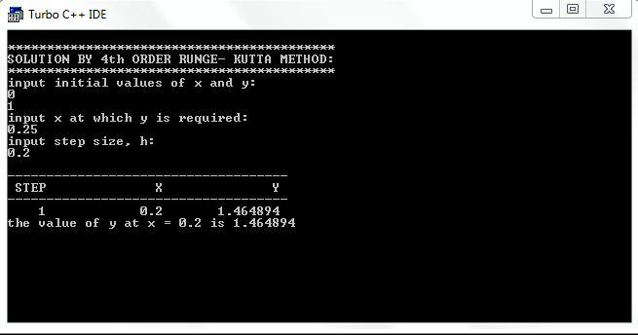

Page 51

